BIN381 - Milestone 3
Jandre Neethling - 601304
Henri Claassen - 601720
Declin Vorkel - 601756

Table of Contents
1. Purpose and scope 2
2. Analytical question and modelling tasks 3
3. Data used for modelling 4
4. Predictor selection 5
5. Employment models 6
5.1 Survey-weighted logistic regression 6
Why it was chosen 6
Assumptions 6
Parameters 7
5.2 Decision tree 7
Why it was chosen 7
Starting parameters 7
5.3 Random forest 7
Why it was chosen 8
Starting parameters 8
5.4 Models considered but not used 8
6. Income models 8
6.1 Survey-weighted linear regression 8
6.2 Random forest (regression) 9
6.3 Models considered but not used 9
7. Use of survey weights 9
8. Implementation and reproducibility 9
9. Handover to tuning and evaluation 10
10. Tuning and evaluation design 10
10.1 Household-grouped cross-validation 11
10.2 Baseline models 11
10.3 Evaluation metrics 11
11. Tuning the employment models 12
11.1 Logistic regression and baseline 12
11.2 Decision tree 12
11.3 Random forest 13
11.4 Classification thresholds 13
12. Tuning the income models 14
12.1 Linear regression and baselines 14
12.2 Random forest 14
12.3 Tuned settings 14
13. Test-set evaluation 15
13.1 Employment results 15
13.2 Calibration 16
13.3 Income results 17
13.4 How closely the models agree 17
14. The education × internet interaction 18
14.1 Likelihood-ratio tests 18
14.2 Predicted probabilities for each group 18
14.3 Do the tree-based models use education and internet access? 19
14.4 Sensitivity check without the device predictors 19
15. Model comparison 19
15.1 Employment comparison matrix 20
15.2 Income comparison matrix 20
16. Final model selection 20
16.1 Employment: survey-weighted logistic regression 21
16.2 Income: survey-weighted linear regression 21
17. Limitations carried into Tasks 3 and 4 21
18. Reproducibility of the tuning and evaluation 22
19. Interpretation and Business Evaluation 22
19.1 Assessment Against Success Criteria 23
19.2 What This Means for the Stakeholder 23
19.3 Association, Not Causation 23
19.4 Why the Tree Based Models Show the Pattern Only Weakly 23
19.5 Limitations 23
19.6 Is It Ready to Deploy? 24
20. Ethics, Fairness and Responsible AI Evaluation 24
20.1 Documented Performance Disparities Across Population Groups 24
20.2 Why Population Group Is a Predictor, Not Just a Comparison Axis 24
20.3 Root Cause and Mitigation 24
Mitigation for deployment: 25
20.4 Survey Weighting as an Existing Fairness Safeguard 25
20.5 Uncertainty Communicated Honestly 25
20.6 AI Usage 25
21. Deployment 25
21.1 What is deployed 26
21.2 Deployment strategy 26
21.3 Choice of deployment tool 26
21.4 The application 27
Overview 28
Education × internet 28
Province scenarios 29
Check new data 30
About the model 30
21.5 How the application uses the model without the survey data 31
21.6 Validating and scoring new data 31
21.7 Monitoring, retraining and retirement 32
21.8 Reproducibility and repository 33
22. Conclusion 34
References 35

1. Purpose and scope
When navigating the project folder, look at Shiny-App in the project root that is where the shiny app and the code used for it lives, the datasets folder contains all the datasets produced, the models folder contains the models that were produced, and the scripts folder is where all the actual R notebooks and R scripts are. In the documentation folder there is a folder called rendered documentation, to see any outputted files from the notebooks please refer to that folder.
This document records which models were considered for Milestone 3, why each one was chosen, how they were implemented and tuned in R, how they performed on the test sets, and which model was selected in the end. The Modelling Strategy is covered first we restate the analytical question, identify the modelling task, select candidate models, and explain their assumptions, parameter choices and training procedure. The model tuning and the technical evaluation include household-grouped cross-validation, hyperparameter and threshold tuning, test-set performance, the checks of the education × internet interaction, the comparison matrix and the final model selection. After that, the business and ethical evaluation and the deployment of the selected model in a Shiny app are covered.
The modelling sections describe the models as they were first fitted once, on the training data only, with documented starting parameters and without using the test sets. Tuning, evaluation and selection were then done in a separate notebook, in a fixed order, so that every parameter, threshold and choice was made on the training data before the test sets were used, for the final comparison.
Final model choice: the survey-weighted logistic regression is selected for the employment question and the survey-weighted linear regression for the income question. The random forests predict slightly better, but by too little to outweigh the regressions’ ability to test the education × internet interaction directly.
Contributions: Henri Claassen chose, implemented and fitted the candidate models and he made the shiny app. Jandre Neethling did the tuning, technical evaluation, model comparison and final model selection, Declin Vorkel handled ethics as well as references and documentation.
The code is in three Quarto notebooks and one shared R script in the project repository:
File | Contents
Scripts/3.1) Employment Model.qmd | Employment question with three classification models
Scripts/3.2) Income Model.qmd | Income question with two regression models
Scripts/3.3) Model Evaluation.qmd | Tuning with household-grouped cross-validation, thresholds, baselines, test set evaluation, interaction checks, comparison matrix and final model selection
R/model_preparation.R | Shared data preparation, predictor lists and model formulas, used by both notebooks and intended for the evaluation notebook and the Shiny app
Models/*.rds | The five models as first fitted with starting parameters (employment_logistic, employment_tree, employment_forest, income_linear, income_forest)
Models/*_tuned.rds, *_baseline.rds | The tuned decision tree and random forests, and the demographics-only baseline models
Models/employment_thresholds.csv | The tuned classification threshold of each employment model, needed by the Shiny app

2. Analytical question and modelling tasks
National Treasury has to decide how to divide limited funding between digital-access subsidies and education programmes. The key question from Milestone 1 is whether household internet access and education reinforce each other or can stand in for each other in the labour market. The Milestone 1 analytics goal was to model employment status from education level, digital access and the interaction between the two.
The Milestone 1 technical success criteria for what the models must deliver:
- The education × connectivity interaction must be tested for statistical significance at α = 0.05.
- Its direction (reinforcing or substituting) must be reported as an odds ratio or equivalent effect size.
- The model must achieve acceptable discriminative performance on a test set.
- The findings must be checked across at least two modelling approaches, such as logistic regression and a tree-based method.
This leads to two modelling tasks:
Question | Task | Outcome | Data
Is education associated with employment, and does internet access strengthen or replace that link? | Binary classification | employed (Employed / Unemployed) | model_train.csv: labour force aged 15-64
Among employed people, is income related to education and internet access? | Regression | log_salary (log of monthly salary) | income_train.csv: employed people who reported a salary of at least R100

Clustering was not chosen, because both questions have a known outcome. A supervised model is needed to estimate how the outcome relates to education and internet access. All results are associations, not causes.

3. Data used for modelling
The models use the validated Milestone 2 training files derived from Statistics South Africa's 2024 General Household Survey (Statistics South Africa, 2025). The Milestone 2 validation design is preserved the train/test split was made by household (80% of households for training), so no household appears in both sets, and the test sets are left untouched for evaluation.
Both notebooks read their data through a shared function in R/model_preparation.R. The same functions are used for the test sets and for new data in the Shiny app, so every file is prepared identically.
The functions:
- Read household_id as text.
- Apply fixed category levels and reference levels, written out in the script rather than taken from the data, so that training, test and new data always get identical factors.
- Leave out rows with unknown education and, for income, unknown household internet.
- Keep only the design columns, the outcome and the chosen predictors.
None of these steps learn anything from the data, so they cannot leak information from the test set. Rows with unknown education are left out rather than imputed they are a small share, education is the variable the question is about and leaving them out means every model is fitted and later compared on exactly the same people.
Training file | Rows in file | Rows removed | Rows used | Households
model_train.csv | 23,041 | 370 (unknown education) | 22,671 | 13,298
income_train.csv | 14,371 | 316 (unknown education or internet) | 14,055 | 10,272
The employment target is mildly imbalanced (65% employed, 35%). This is not severe enough to need resampling such as SMOTE or down-sampling, so all models are fitted to the data as they are. How the smaller Unemployed class is handled at prediction time is left to tuning.

4. Predictor selection
The file model_data.csv has 21 candidate predictors, several of which measure the same thing in different ways. Putting overlapping columns in one model splits a single effect across several coefficients, makes the interaction hard to read and can make the estimates unstable. One version of each idea was therefore kept:
Kept | Left out | Reason
matric_plus (0/1) | education_band | The policy question is framed as with or without matric. A 0/1 variable gives the interaction one odds ratio instead of six, which answers the question directly.
any_home_internet (0/1) | has_fixed_internet, has_mobile_internet, digital_access_score | Internet access is the policy lever. The other columns are its parts, or a score that includes it, so using them together would count the same access twice.
has_computer, smartphone_access |  | Separate controls for other kinds of digital access, so the internet effect is not simply device ownership, which also reflects household wealth.
matric_plus × any_home_internet (in the regression formula) | edu_digital_group | edu_digital_group is the same combination stored as one categorical column. Using both would duplicate the interaction.
household_size, n_children_under15, elderly_in_household, female_x_children, other_member_matric | dependency_ratio | dependency_ratio is calculated from the counts of children, elderly and working-age members that the other household columns already describe.
age_centred, age_centred_squared, female, population_group, province, settlement_type |  | Standard labour-market controls. Without them the internet effect would partly be an age, gender, location or population-group effect.

This gives 15 predictors for the employment models. The income file was built with fewer columns in Milestone 2, so the income models use the 8 that apply: matric_plus, any_home_internet, the two age terms, female, population_group, province and settlement_type. The same choices were made in both, so the two sets of models can be compared.
The population_group is a sensitive attribute. It is included as a control, so that the education and internet effects are estimated within population groups rather than being confounded with South Africa's historical inequality. It is also needed for fairness checks during evaluation. It is not meant for predicting outcomes for individual people.
The household_id and person_weight columns are never predictors. The household_id defines the clusters in the survey design and person_weight is the Stats SA survey weight.
Two checks were run before fitting, namely the correlation between the numeric household predictors is at most about 0.8, which is high, but not so high that the coefficients become unstable, and both are controls rather than the effects of interest. Each of the four matric × internet groups also has enough people to estimate the interaction. The smallest one is people with matric but no home internet, has 1,016 people in the employment training data and 555 in the income training data.

5. Employment models
Three models were chosen. They answer the question in different ways and they are not only competing on accuracy, since highest accuracy should not be the only measure taken to determine the best model.
Model | Role | Main reason for choosing it
1. Survey-weighted logistic regression (survey::svyglm) | Main explanatory model | The only candidate that estimates the education × internet interaction directly as an odds ratio with a significance test.
2. Decision tree (rpart) | Interpretable tree-based check | Finds interactions without being told about them, and produces rules that non-technical stakeholders can follow.
3. Random forest (ranger) | Predictive benchmark | Captures non-linear effects and interactions the regression cannot. Shows how much predictive power the simpler models give up.

5.1 Survey-weighted logistic regression

Why it was chosen
Logistic regression is the standard model for a binary outcome, and it is the only candidate whose output directly answers Treasury's question. With the interaction matric_plus × any_home_internet in the model, the exponentiated interaction coefficient is an odds ratio: above 1 means internet access goes with a larger employment advantage for people with matric and below 1 means a smaller one. It comes with a confidence interval and p-value, so it can be tested at α = 0.05 as Milestone 1 requires. Every other coefficient is also an interpretable odds ratio, which suits a policy stakeholder who needs to explain the result.
The survey-weighted version was chosen over an ordinary glm() (Lumley, 2004) for two reasons. First, Stats SA sampled some groups more heavily than others (Statistics South Africa, 2025), and the person weights correct for this, so the odds ratios describe the South African labour force rather than the sample. Second, people in the same household are not independent, because they share every household-level predictor. Treating households as clusters gives standard errors, and so a significance test for the interaction, that allow for this. An ordinary glm() would treat all 22,671 people as independent and understate the uncertainty.

Assumptions
Assumption | How it is handled
Binary outcome | Employed has two levels, with Unemployed as the reference, so the model predicts the probability of being Employed.
Independent observations | Households are the clusters in the survey design. The Stats SA primary sampling unit is not in model_data.csv, so the household is the finest cluster available.
Log-odds linear in the numeric predictors | Age has a curved relationship with employment, so age_centred_squared is included next to age_centred.
No strong multicollinearity | Overlapping predictors were removed. The remaining correlations are acceptable.
Enough cases per parameter | About 8,000 unemployed people for 30 coefficients, far above the usual minimum of 10-20 events per coefficient.

Parameters
- The family = quasibinomial(): the logistic link. svyglm uses the quasi-binomial family with survey weights, because weighted counts are not whole numbers. The coefficients are identical to binomial().
- Survey design: ids = ~household_id, weights = ~person_weight.
- Formula: employed ~ matric_plus * any_home_internet + the 13 control predictors.
- No hyperparameters to tune. Only the classification threshold is left for evaluation.

5.2 Decision tree

Why it was chosen
Milestone 1 committed to checking the findings with a tree-based method. A decision tree is the most interpretable tree-based model because it splits the data into groups using simple if-then rules. It makes no assumptions about linearity, handles categorical predictors directly and finds interactions on its own. If it splits on internet access differently for people with and without matric, that is independent support for the regression's interaction. If it does not, that is also informative for evaluation. Its rules can also be shown to non-technical stakeholders as a diagram.

Starting parameters
Parameter | Value | Reason
method | "class" | Classification tree for the two-level target.
maxdepth | 5 | At most five questions from the top of the tree to a prediction. A deeper tree is no longer readable, and readability is why a tree was chosen.
minbucket | 100 | Every final group contains at least 100 people. This keeps the groups stable and avoids rules that describe very small, possibly identifiable groups.
cp | 0.001 | A split is kept if it improves the fit by at least 0.1%. Low on purpose: maxdepth and minbucket limit the size, and pruning is left to tuning.
xval | 0 | rpart's built-in cross-validation is switched off, because it splits by person, which would put members of one household on both sides and overstate performance.

The tree uses the same 15 predictors as the regression, but without an explicit interaction term, because a tree forms interactions itself by splitting on one variable inside a split on another.

5.3 Random forest

Why it was chosen
A random forest grows many decision trees on bootstrap samples of the data, with each split considering only a random subset of the predictors, and averages their predictions. This gives more accurate and more stable predictions than a single tree, and it captures non-linear effects and complex interactions that the logistic regression's form rules out. Its role is a benchmark if it predicts only slightly better than the logistic regression, the interpretable model loses little by being simple, which supports choosing it. It also provides a second check, if education and internet access remain important predictors in the forest, the finding does not depend on the regression's assumptions.
The ranger package was used instead of randomForest (Wright and Ziegler, 2017), because it implements the same algorithm much faster and handles categorical predictors better.

Starting parameters
Parameter | Value | Reason
num.trees | 500 | Enough trees for predictions and importance scores to stabilise. More only cost time.
mtry | 3 | Predictors considered at each split: the standard √15 ≈ 3 for classification. The main tuning parameter.
min.node.size | 10 | The standard minimum leaf size for probability forests.
probability | TRUE | Predicts the probability of being employed rather than a class, so the threshold can be chosen and ROC-AUC calculated during evaluation.
respect.unordered.factors | "order" | Orders the levels of each categorical predictor by their share of employed people before splitting, instead of treating an arbitrary level order as meaningful.
importance | "permutation" | Measures how much predictions worsen when a predictor is shuffled. More reliable than impurity importance, which favours predictors with many levels.
seed | 67 | Makes the forest reproducible.

5.4 Models considered but not used
- Penalised logistic regression (lasso/ridge): useful with many predictors. With 15 chosen predictors and over 20,000 rows a standard logistic regression is stable, and penalisation would shrink the interaction coefficient the question is about.
- k-nearest neighbours and support vector machines: give no interpretable effect sizes, and need scaled numeric inputs that do not suit mainly categorical predictors.
- Neural networks: a black box with no clear advantage on 15 tabular predictors, and hard to justify to a policy stakeholder.
- Gradient boosting (e.g. XGBoost): could be slightly more accurate than a random forest, but it needs much more tuning, and the forest already fills the benchmark role.
- Clustering: the question has a known outcome, so a supervised model is appropriate.

6. Income models
The income question is exploratory. Salaries are missing for a large share of employed people, so the results describe people who reported a salary, not all employed people. Two models were chosen, meeting the requirement of at least two candidates and pairing a linear model with a tree based model as for employment.

6.1 Survey-weighted linear regression
Why it was chosen: the outcome log_salary is continuous, so linear regression is the natural interpretable model. Using the log of salary reduces the strong right skew of salaries and means each coefficient can be read as a percentage difference in salary. With the same matric_plus × any_home_internet interaction as the employment model, it shows whether the salary premium for matric is larger or smaller in connected households, with a confidence interval and significance test. As for employment, the survey-weighted version with households as clusters gives population-representative estimates and correct standard errors.
Assumptions: a linear relationship with the numeric predictors, roughly normal errors with constant variance and independent observations.
Parameters: family = gaussian(), design ids = ~household_id, weights = ~person_weight, no hyperparameters to tune.

6.2 Random forest (regression)
Why it was chosen: the forest predicts log_salary without assuming a linear shape and finds interactions itself. It is the benchmark for the linear model it shows whether the linear model misses important structure, and whether education and internet access remain important predictors of income without the linear model's assumptions.
Starting parameters: num.trees = 500, mtry = 2, min.node.size = 5, respect.unordered.factors = "order”, importance = "permutation", seed = 67.

6.3 Models considered but not used
- A single regression tree: the readable-tree role is already covered by the employment model, and the income question is exploratory.
- Gamma or log-normal GLM on raw salary: gives much the same answer as a linear model of log_salary, but is harder to explain.
- Quantile regression: would show effects at low and high salaries separately. It can be a possible extension, but it is beyond what the business question asks.

7. Use of survey weights
The regression models are survey-weighted and the tree-based models are not (Lumley, 2004). This was a deliberate choice:
- The regression models are used to estimate effects for the population, so they must be representative. Survey weighting and household clustering are what make those estimates and their significance tests valid.
- The tree-based models are used to check the pattern and benchmark predictive performance, not to produce population estimates. The weights range from 50 to 5,531. In rpart a weighted tree would let a small number of heavily weighted people decide the splits, and in ranger weights become bootstrap sampling probabilities, so the most heavily weighted people would appear in almost every tree. Both would reduce the effective amount of data.
Weights are not lost for these models, thus the evaluation can still pass person_weight to the performance metrics to report population-weighted results next to the unweighted ones.

8. Implementation and reproducibility
- All models are built in R with survey (Lumley, 2026), rpart (Therneau and Atkinson, 2026), rpart.plot and ranger, on the Milestone 2 training files only.
- Data preparation, predictor lists and formulas are defined once, in R/model_preparation.R, and shared by every notebook, which ensures no model can be trained on data prepared differently.
- Every random step uses a seed value of 67, the same seed as the Milestone 2 split, so rerunning the notebooks gives identical models and ensures they are reproducible.
- No preprocessing step learns from the data so there is no preprocessing leakage from the test set and the only learned parameters are the models own, fitted on training data.
- Each notebook includes verification checks: row counts before and after preparation, no remaining missing values, no unexpected category values and that every training row was used in the fit.
- The fitted models are saved to the Models/ folder and each notebook reloads them and confirms that they give identical predictions to the models in memory.

9. Handover to tuning and evaluation
The parameters above are starting values, not tuned values. The following is left for the tuning and evaluation stage:
Model | To tune
Logistic regression | Classification threshold only
Decision tree | cp (pruning), maxdepth, minbucket, and the threshold
Random forest (employment) | mtry, min.node.size, and the threshold
Linear regression (income) | Nothing
Random forest (income) | mtry, min.node.size

To keep tuning free of leakage, cross-validation should be grouped by household for the same reason the train/test split was. Parameters and thresholds should be chosen on the training folds only, and each test set used once, for the final comparison. The test sets must be prepared with the same functions and the notebooks show the code for loading each saved model and producing predictions.
This handover was carried out as planned.

10. Tuning and evaluation design
Tuning and evaluation are done in “Scripts/3.3) Model Evaluation.qmd”. It continues from the two modelling notebooks: it reads the training files through the same preparation functions, loads the saved models and tunes the models that have hyperparameters. The notebook works in a fixed order, so that the test sets cannot influence any choice:
Step | Data used | What happens
1. Folds | Training files only | Household-grouped cross-validation folds are built and checked.
2. Tuning | Training files only | The tree and forest parameters are tuned, the baselines are cross-validated and each employment model’s classification threshold is chosen, all from out-of-fold predictions.
3. Refit | Training files only | The tuned models are refitted on the full training files and saved.
4. Test | Test files, used once | Every model is scored on the test sets with the parameters and thresholds fixed in steps 2-3.
5. Interaction | Training files and fitted models | The education × internet interaction is tested and checked across the models.
6. Selection | Results of steps 2-5 | Comparison matrix and final model selection.

10.1 Household-grouped cross-validation
Tuning needs data the model was not fitted on, but the test set must stay untouched until the end. Five-fold cross-validation solves this with the training data alone: the training rows are divided into five folds, each model is fitted five times on four folds and scored on the fifth, and the five results are averaged. Every training row therefore gets one “out-of-fold” prediction from a model that never saw it.
The folds are grouped by household with caret::groupKFold (Kuhn, 2026) for the same reason the Milestone 2 train/test split was: members of one household share every household-level predictor (internet access, computer, smartphones, household size), so splitting a household across folds would score the model on near-copies of people it was trained on and overstate its performance. The seed is set to 67 first and in each fold the survey design of the regressions is rebuilt from that fold’s training rows only.
The folds were checked before use: every row is in exactly one fold, no household is split across folds and the share of employed people is similar in every fold, so each fold is a fair small-scale copy of the training data.

10.2 Baseline models
The success criteria we created requires the models to be compared with a demographics-only baseline: a model that knows a person’s age, sex, population group, province and settlement type, but nothing about their education, digital access or household. If the full models do not predict clearly better than the baseline, education and digital access add little predictive information beyond who and where a person is. Each baseline is a survey-weighted regression with the same design as the main regression, so the only difference between the two is the predictors, like for income, the simplest possible baseline (predicting everyone’s salary as the weighted training average) is also included.

10.3 Evaluation metrics
No single metric is enough, so each task gets several that measure different things. About 35% of the labour force is unemployed, so a model that always predicts Employed would already be 65% accurate: accuracy on its own is misleading and is not used to choose anything.

Metric | What it measures | Why it is used
ROC-AUC | How well the predicted probabilities rank employed people above unemployed people, over every threshold | Main tuning and comparison metric. Independent of the threshold and class balance. Milestone 2 set AUC ≥ 0.70 as the minimum.
Balanced accuracy | Average of sensitivity and specificity | Treats both classes as equally important.
Sensitivity / specificity | Share of employed / unemployed people classified correctly | Specificity covers the smaller class, the one policy is most concerned with.
Precision, F1 | Share of Employed predictions that are correct. Balance of precision and sensitivity | Required by the brief’s list of classification metrics.
Brier score | Mean squared difference between predicted probability and outcome (0 = perfect) | The Shiny app shows probabilities, so they must be accurate, not only well ranked.
RMSE, MAE, R² (income) | Size of the errors on the log-salary scale, and the share of variation explained | Standard regression metrics, on the scale the models were fitted on.
Every test-set metric is reported unweighted and weighted by person_weight.

11. Tuning the employment models

11.1 Logistic regression and baseline
The logistic regression has no hyperparameters, but it is still cross-validated: its out-of-fold predictions give a cross-validated AUC to compare with the other models and are used to choose its threshold. Its mean cross-validated AUC is 0.764, against 0.723 for the demographics-only baseline.

11.2 Decision tree
Three parameters control the tree’s size and were tuned together over a grid of 36 combinations, each fitted once per fold. rpart’s own cross-validation stays switched off, because it splits by person.

Parameter | Values tried | Reason for the range
maxdepth | 3, 4, 5 | Not above 5, because the tree was chosen for readability.
minbucket | 50, 100, 200 | Not below 50, so no rule describes a very small, possibly identifiable group.
cp | 0.0005, 0.001, 0.002, 0.005 | Minimum improvement a split must give to be kept (pruning).

Many settings gave almost the same AUC, with differences smaller than the variation between folds. The tree was therefore chosen with the one-standard-error rule (Breiman et al., 1984): among all settings whose mean AUC is within one standard error of the best, the tree with the fewest leaves is chosen. This picks the simplest tree that performs as well as the best one within the precision the cross-validation can measure, which suits a model chosen for being readable.
The best setting of maxdepth 5, minbucket 100, cp 0.0005 and 12 leaves had a cross-validated AUC of 0.7131, giving a limit of 0.7079. The selected tree has maxdepth = 5, minbucket = 200 and cp = 0.001, with 9 leaves and a cross-validated AUC of 0.7106. The best trees all use the maximum depth, so the depth limit set for readability costs some accuracy: even the best tree is below the demographics-only baseline (0.723).
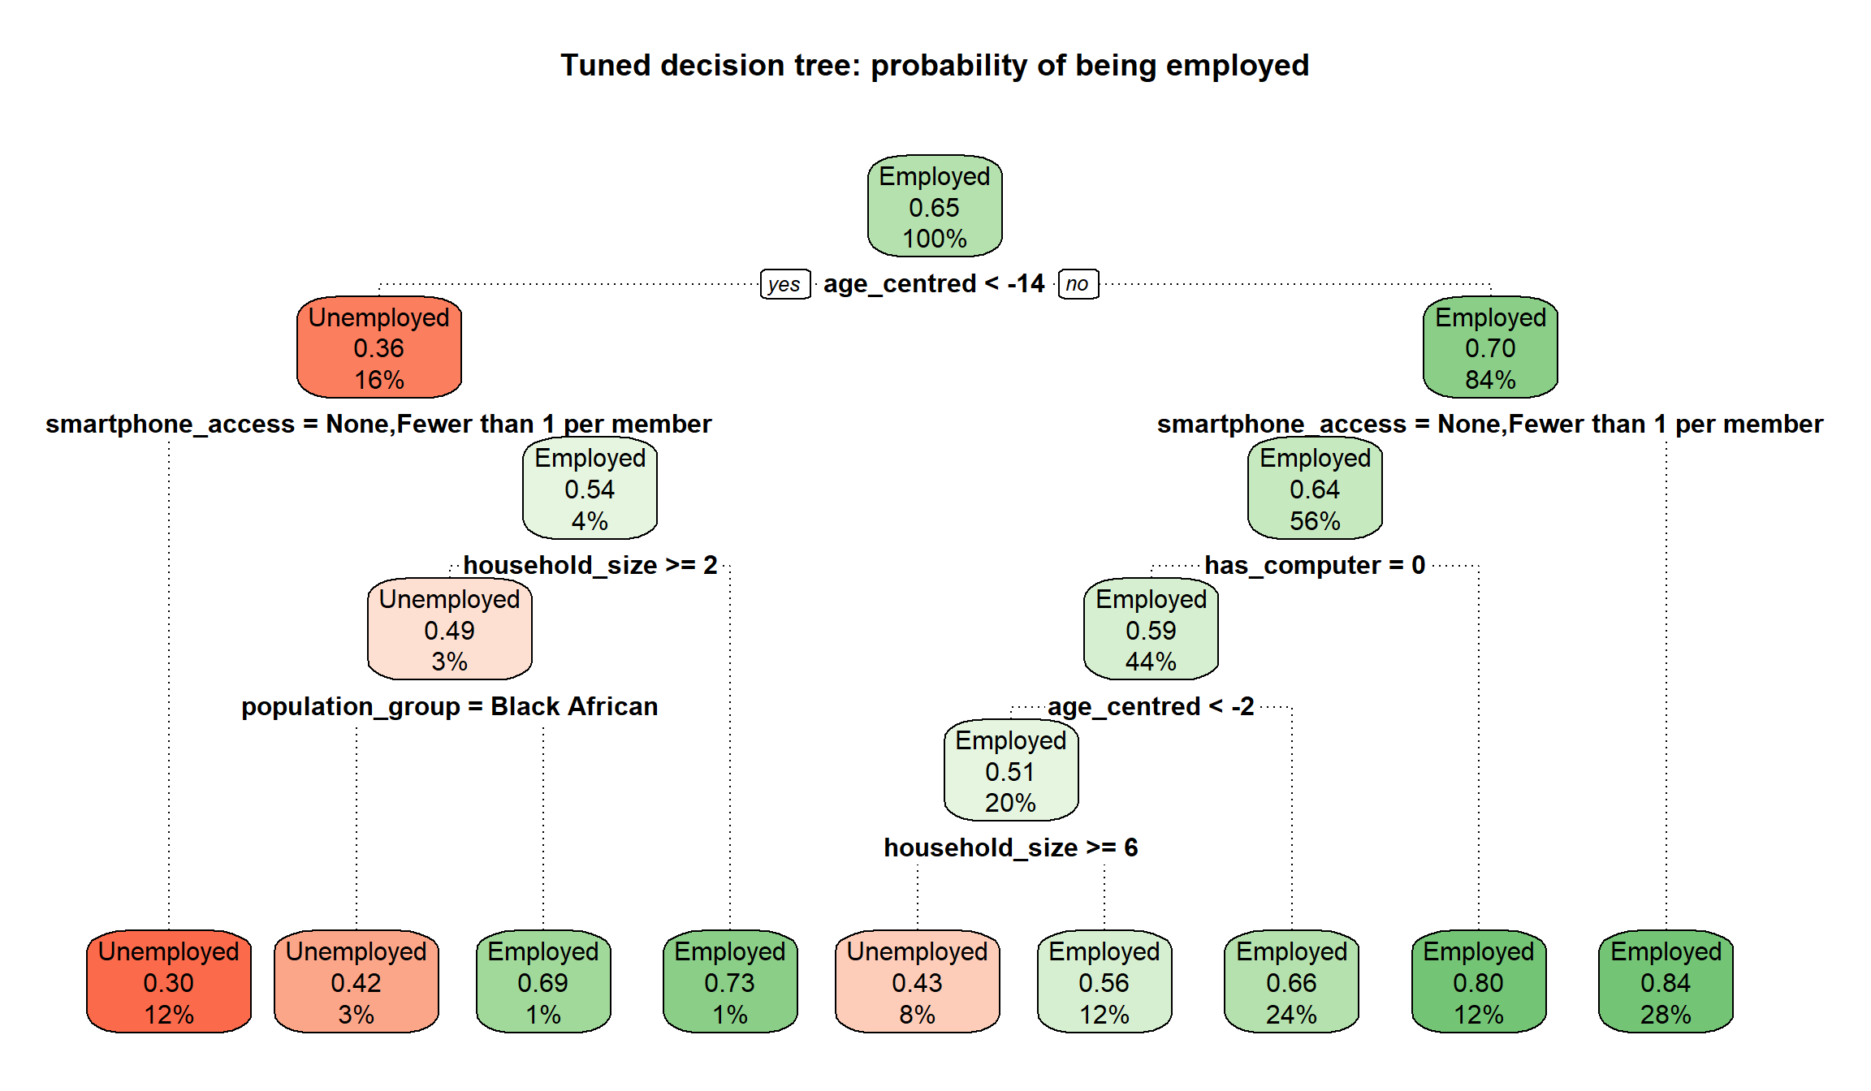
The tuned tree splits only on age, smartphone access, computer ownership, household size and population group. It never splits on matric_plus or any_home_internet, so it cannot show an education × internet interaction.

11.3 Random forest
The forest’s main parameters are mtry and min.node.size. num.trees is not tuned, because more trees only make the predictions more stable: 300 trees were grown during tuning to save time and the final forest has 500. The forest is chosen by the highest mean cross-validated AUC. The one-standard-error rule is not used, because the forest is not meant to be readable.
Parameter | Values tried | Reason for the range
mtry | 2, 3, 4, 6 | Small values make the trees more different from each other. Large values let each split use the strongest predictors. 3 (√15) was the starting value.
min.node.size | 10, 30, 100, 200, 400 | 10 was the starting value. A first run that stopped at 100 chose 100, the edge of the grid, so larger values were added.

The selected forest uses mtry = 3 and min.node.size = 100, with a cross-validated AUC of 0.771, against 0.763 for the starting values. Small leaves let each tree fit individual people too closely. Larger leaves give smoother probabilities that rank people better.

11.4 Classification thresholds
A model’s probabilities become Employed/Unemployed predictions through a threshold. The default of 0.5 is only right when both kinds of error are equally costly and the classes are balanced. With 65% employed, a 0.5 threshold labels most people Employed and misses many of the unemployed. Each model’s threshold was chosen from its out-of-fold predictions (never the test set) as the threshold that maximises balanced accuracy, which gives both classes equal importance.
Model | Tuned threshold | Balanced accuracy at 0.5 | Balanced accuracy tuned | Specificity at 0.5 | Specificity tuned
Baseline | 0.674 | 0.634 | 0.659 | 0.393 | 0.683
Logistic regression | 0.639 | 0.660 | 0.695 | 0.456 | 0.678
Decision tree | 0.616 | 0.629 | 0.656 | 0.378 | 0.536
Random forest | 0.654 | 0.659 | 0.701 | 0.440 | 0.726

At 0.5 every model identifies fewer than half of the unemployed. The tuned thresholds, all between 0.6 and 0.7, trade some sensitivity for much higher specificity and raise balanced accuracy for every model. Accuracy falls slightly, as expected, because the larger class is now predicted less often. The thresholds are saved in Models/employment_thresholds.csv, because they are part of each classification model and the Shiny app needs them.

12. Tuning the income models

12.1 Linear regression and baselines
The linear regression has no hyperparameters. Its cross-validated performance, with the two baselines:
Model | CV RMSE | CV MAE | CV R²
Training average | 1.149 | 0.903 | −0.012
Baseline (demographics only) | 1.037 | 0.794 | 0.176
Linear regression | 0.948 | 0.727 | 0.311

12.2 Random forest
mtry was tried over its full range for 8 predictors and min.node.size over 5, 20, 50, 100 and 200. The setting with the lowest mean cross-validated RMSE was chosen: mtry = 3 and min.node.size = 200. This is again at the edge of the grid, but the grid was not extended: the ten best settings differ in mean RMSE by only 0.0028, well below the fold-to-fold standard deviation of about 0.004, so larger leaves could not give a meaningful improvement.

12.3 Tuned settings
The chosen settings were used to refit each tuned model on the full training file.The regressions have nothing to tune, so the models saved by the modelling notebooks are used unchanged. The untuned models stay in Models/ as the documented starting point, and the tuned models are saved next to them with _tuned in the name.

Setting | Starting value | Tuned value
Tree maxdepth | 5 | 5
Tree minbucket | 100 | 200
Tree cp | 0.001 | 0.001
Employment forest mtry | 3 | 3
Employment forest min.node.size | 10 | 100
Income forest mtry | 2 | 3
Income forest min.node.size | 5 | 200

13. Test-set evaluation
From this point nothing is tuned or chosen. The test sets are read with the same preparation functions and checked: the employment test set has 5,574 people in 3,317 households (35.5% unemployed), the income test set 3,560 people in 2,569 households, and neither shares a single household with its training set.

13.1 Employment results
Metric | Baseline | Logistic regression | Decision tree | Random forest
AUC | 0.727 | 0.765 | 0.710 | 0.774
AUC 95% CI (DeLong) | 0.713-0.741 | 0.752-0.778 | 0.696-0.724 | 0.761-0.786
Balanced accuracy | 0.664 | 0.693 | 0.656 | 0.699
Sensitivity | 0.641 | 0.707 | 0.764 | 0.671
Specificity | 0.687 | 0.679 | 0.549 | 0.728
Precision | 0.788 | 0.801 | 0.755 | 0.817
F1 | 0.707 | 0.751 | 0.760 | 0.737
Accuracy | 0.658 | 0.698 | 0.688 | 0.691
Brier score | 0.194 | 0.183 | 0.198 | 0.180
AUC, population-weighted | 0.732 | 0.770 | 0.711 | 0.779

The test results are close to the cross-validated results, so the cross-validation gave a realistic estimate and the models are not overfitted. Every model clears the AUC ≥ 0.70 threshold set in Milestone 2, including the demographics-only baseline, so that threshold on its own does not separate the models. The comparison with the baseline is what shows whether education, digital access and the household predictors add anything. The population-weighted metrics are very similar to the unweighted ones.
Model | Employed correctly identified | Employed predicted Unemployed | Unemployed correctly identified | Unemployed predicted Employed
Baseline | 2,306 | 1,290 | 1,359 | 619
Logistic regression | 2,544 | 1,052 | 1,344 | 634
Decision tree | 2,749 | 847 | 1,085 | 893
Random forest | 2,412 | 1,184 | 1,439 | 539
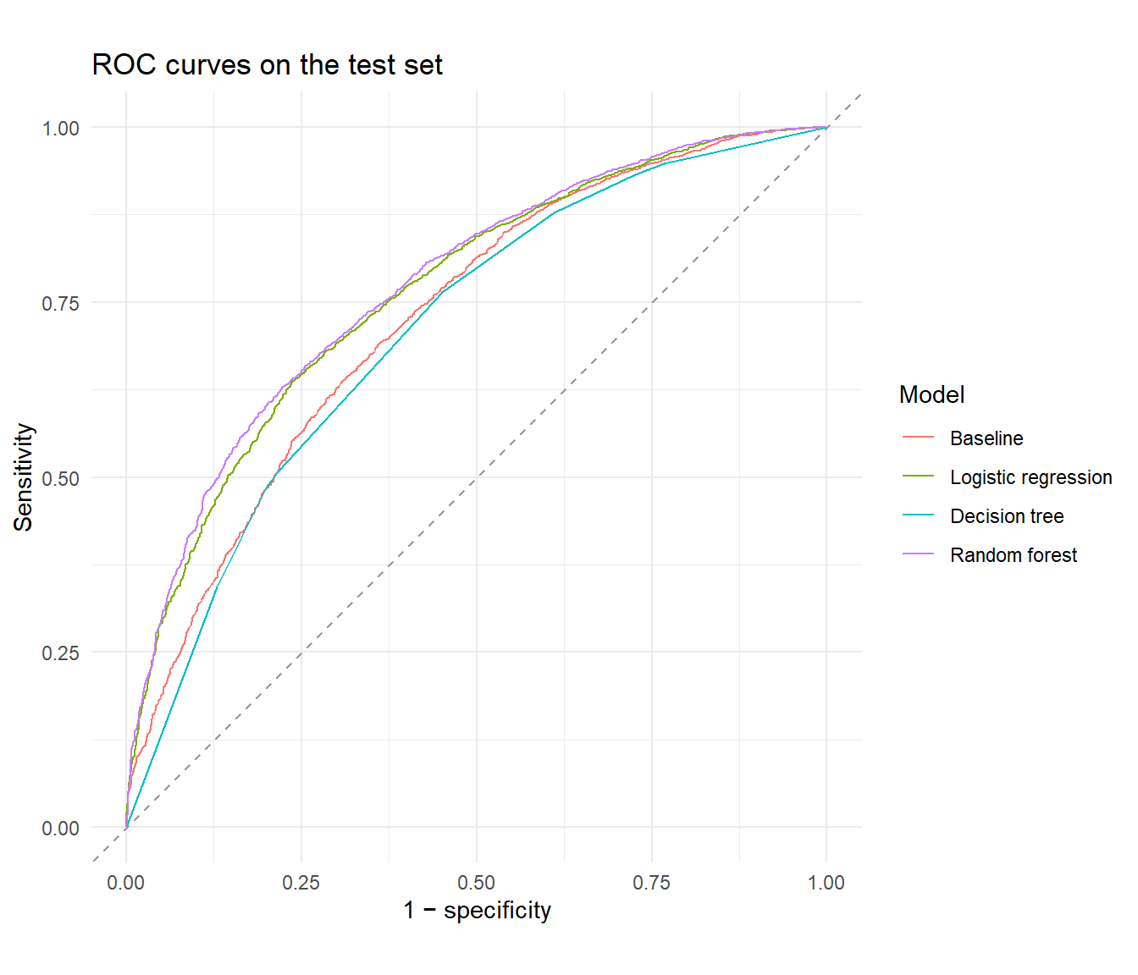
The DeLong test (DeLong, DeLong and Clarke-Pearson, 1988) checks whether the difference in AUC between two models on the same test people is larger than chance. Each model was compared with the logistic regression:
Comparison | AUC difference | DeLong p-value
Logistic regression vs baseline | +0.038 | < 0.0001
Logistic regression vs decision tree | +0.055 | < 0.0001
Logistic regression vs random forest | -0.009 | 0.0019

The DeLong test treats people as independent. Household members are not fully independent, so these p-values are somewhat too small, and a difference that is only just significant should be read with caution.

13.2 Calibration
The Shiny app will show predicted probabilities, so they should match reality: of the people given a 70% probability, about 70% should be employed. The test people were grouped into ten equal-sized bins by predicted probability, and each bin’s average prediction was compared with its actual share employed. All four models lie close to the diagonal across the whole range, so none is systematically too confident or too cautious.
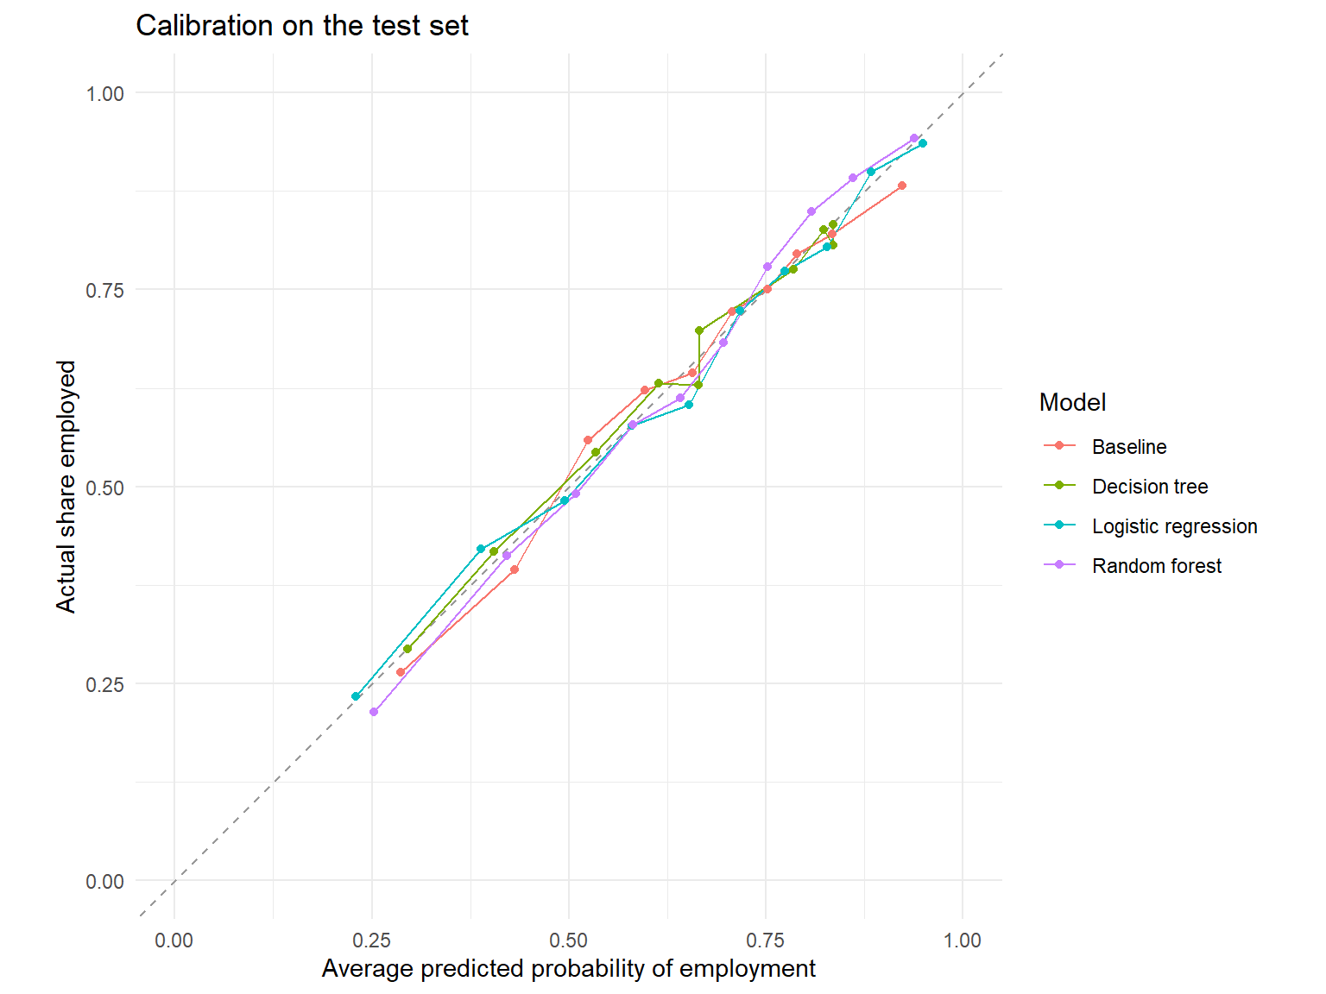

13.3 Income results
Model | RMSE | MAE | R² | R², population-weighted
Training average | 1.145 | 0.900 | −0.021 | −0.001
Baseline (demographics only) | 1.038 | 0.795 | 0.161 | 0.187
Linear regression | 0.949 | 0.729 | 0.298 | 0.315
Random forest | 0.937 | 0.716 | 0.316 | 0.329

Both models clearly beat the two baselines, and the test results match the cross-validated ones. Even so, both explain only about 30% of the variation in log salary: education, internet access, age, sex, population group and location leave most salary differences unexplained. An RMSE of about 0.95 on the log scale means an individual prediction is typically off by a factor of about 2.6 in rand terms, so the income models are useful for average differences between groups, not for predicting an individual’s salary.
The residuals of the linear regression are centred on zero across the whole range of fitted values with roughly constant spread, so the linear form and the constant-variance assumption hold reasonably well. The Q-Q plot shows heavier tails than a normal distribution. With over 14,000 people this does not affect the coefficients or their confidence intervals much.

13.4 How closely the models agree
The metrics show how well each model predicts, but not whether the models make the same predictions. The test-set predictions of each pair of models were therefore correlated, and the agreement of their final classifications was measured with Cohen’s kappa.
- The logistic regression and the random forest correlate at 0.93 and give the same class to 89% of test. The forest’s extra flexibility finds very little the regression misses.
- For income, the linear regression and the forest correlate at 0.96. Both correlate with the actual log salary at only about 0.55: they capture the same group differences and miss the same individual variation.
- The decision tree agrees least with the other models, because it sorts everyone into only 9 groups.
- The baseline correlates at 0.86 with the logistic regression and 0.81 with the forest. That difference is the information that education, digital access and the household predictors add.

14. The education × internet interaction
Our original criteria require the interaction to be tested with a likelihood-ratio test at α = 0.05, reported as an odds ratio and as predicted probabilities for each education × internet group and checked with at least two modelling approaches.

14.1 Likelihood-ratio tests
regTermTest(..., method = "LRT") compares each regression with and without the interaction term using the Rao-Scott likelihood-ratio test, which adjusts the ordinary test for the survey weights and household clustering (Rao and Scott, 1981).
Model | Interaction effect | 95% CI | LRT p-value | Significant at 0.05
Employment (logistic regression) | Odds ratio 1.292 | 1.057-1.580 | 0.013 | Yes
Income (linear regression) | +3.1% salary difference |  | 0.597 | No

For employment the interaction is significant and above 1: home internet goes with a larger employment advantage for people with matric, so education and internet access act as complements. For income there is no evidence that home internet changes the salary premium for matric.

14.2 Predicted probabilities for each group
An odds ratio is hard to explain to a non-technical reader, so each model’s predictions were also turned into the average probability of employment for the four education × internet groups. Every training person was given each group’s matric_plus and any_home_internet values in turn, with all their other characteristics unchanged and the predictions were averaged with person_weight. The interaction on the probability scale is the extra gain from having both: (both - internet only) - (matric only - neither).
Model | Neither | Internet only | Matric only | Both | Interaction
Logistic regression | 0.609 | 0.628 | 0.635 | 0.697 | +0.044
Decision tree | 0.652 | 0.652 | 0.652 | 0.652 | 0.000
Random forest | 0.608 | 0.628 | 0.644 | 0.677 | +0.014
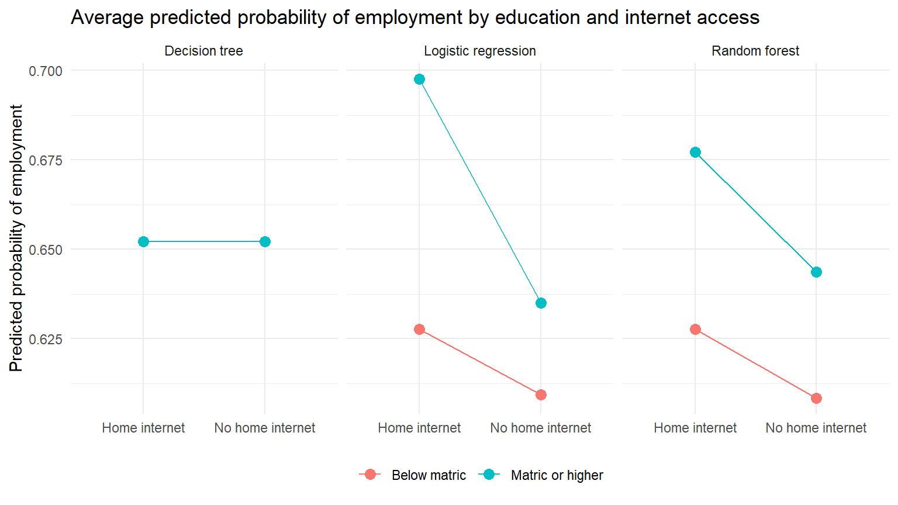
The logistic regression and the random forest agree on the direction: people with matric gain more from home internet than people without matric. The Radom Forest Model was not told about the interaction and found the same complements pattern on its own, although its estimate is smaller, partly because it averages many trees that often do not split on these two predictors. The decision tree gives the same probability to all four groups because it never splits on education or internet access.

14.3 Do the tree-based models use education and internet access?
The tuned tree does not split on either variable, and the forest ranks matric_plus 11th and any_home_internet last by permutation importance. Age, household size and the device predictors drive its predictions. There are two reasons, both about the data rather than the models: about 85% of the labour force lives in a household with internet access, so splitting on it separates only a small group, and almost everyone with home internet also has a smartphone in the household, so once a tree has split on smartphone_access, any_home_internet adds little. Low importance does not mean internet access is unrelated to employment, only that other predictors carry the same information for prediction.

14.4 Sensitivity check without the device predictors
has_computer and smartphone_access are strongly linked to home internet and may absorb part of its effect. The logistic regression was therefore refitted without them:
Term | Odds ratio with devices (95% CI) | Odds ratio without devices (95% CI)
matric_plus | 1.148 (0.952-1.383) | 1.337 (1.111-1.608)
any_home_internet | 1.103 (0.942-1.291) | 1.433 (1.262-1.628)
matric_plus × any_home_internet | 1.292 (1.057-1.580) | 1.278 (1.046-1.562)
Interaction LRT p-value | 0.013 | 0.018

The interaction hardly changes and is significant in both versions, so the complements finding does not depend on whether the devices are controlled for. The main effects do change: without the devices, matric and home internet are each clearly associated with higher odds of employment on their own. With them, the internet main effect is small and not significant, because smartphone_access carries most of the same information. The report uses the version with the devices, since that is the selected model.

15. Model comparison

15.1 Employment comparison matrix
Criterion | Baseline | Logistic regression (selected) | Decision tree | Random forest
Cross-validated AUC | 0.723 | 0.764 | 0.711 | 0.771
Test AUC (95% CI) | 0.727 (0.713-0.741) | 0.765 (0.752-0.778) | 0.710 (0.696-0.724) | 0.774 (0.761-0.786)
Test AUC gain over baseline | 0.000 | +0.038 | −0.017 | +0.047
Meets AUC ≥ 0.70 | Yes | Yes | Yes | Yes
Balanced accuracy | 0.664 | 0.693 | 0.656 | 0.699
Specificity | 0.687 | 0.679 | 0.549 | 0.728
Brier score | 0.194 | 0.183 | 0.198 | 0.180
Interpretability | High (odds ratios) | High (odds ratios) | High (if-then rules) | Low (black box)
Tests the interaction | No (no education or internet predictors) | Yes (odds ratio and LRT) | No (does not split on either) | Indirectly (group averages)
Uses survey weights | Yes | Yes | No | No

15.2 Income comparison matrix
Criterion | Training average | Baseline | Linear regression (selected) | Random forest
Cross-validated RMSE | 1.149 | 1.037 | 0.948 | 0.943
Test RMSE | 1.145 | 1.038 | 0.949 | 0.937
Test MAE | 0.900 | 0.795 | 0.729 | 0.716
Test R² | −0.021 | 0.161 | 0.298 | 0.316
Interpretability | Trivial | High (% differences) | High (% differences) | Low (black box)
Tests the interaction | No | No | Yes (coefficient and LRT) | Indirectly

16. Final model selection
The brief’s key principle is that the highest-scoring model is not automatically the best one. The selection therefore weighs the test results, the interaction checks and the comparison matrix against what each model has to deliver: an answer to Treasury’s complements-or-substitutes question, acceptable performance on the held-out test set and probabilities that can be shown in a deployed app.

Question | Selected model | Saved as | Key results
Employment | Survey-weighted logistic regression | Models/employment_logistic.rds, threshold 0.639 | Test AUC 0.765 (baseline 0.727), interaction odds ratio 1.29, LRT p = 0.013: complements
Income | Survey-weighted linear regression | Models/income_linear.rds | Test RMSE 0.949, R² 0.30, interaction +3.1%, LRT p = 0.60: not significant

16.1 Employment: survey-weighted logistic regression
- It meets the performance criterion. Its test AUC is 0.765, above the 0.70 threshold and clearly above the demographics-only baseline. Education, digital access and the household predictors therefore add real predictive information beyond who and where a person is.
- It gives up little against the best-scoring model. The random forest has the highest test AUC of 0.774. The difference of 0.009 is statistically detectable, but small in practice: balanced accuracy 0.693 against 0.699 and Brier score 0.183 against 0.180. Both are well calibrated.
- It is the only model that answers the business question directly. It estimates the education × internet interaction as an odds ratio of 1.29 with a likelihood-ratio test of p = 0.013, as the success criteria require, and the survey weights make that estimate describe the South African labour force. The forest can show the interaction only indirectly, through group averages.
- Its result is robust. The random forest, which was not told about the interaction, finds the same complements pattern, and the interaction barely changes when the device predictors are removed. This is the check across a second modelling approach that success criterion 4 requires.
- It is easier to deploy and explain. Every prediction can be traced to odds ratios a policy stakeholder can read, and a regression is small and fast to score in a Shiny app.
The random forest is kept as the predictive benchmark: it shows that a flexible model gains only about 0.01 AUC over the logistic regression, and its predictions correlate with the regression’s at 0.93. The decision tree is not selected: its test AUC 0.710 is below the demographics-only baseline and it never splits on education or internet access, so it cannot serve as the readable check of the interaction it was chosen for. That role is filled by the random forest instead.

16.2 Income: survey-weighted linear regression
The random forest predicts slightly better with a difference of about 1% in RMSE. That is too small to outweigh the linear regression’s advantages: it reports salary differences as percentages with confidence intervals, it uses the survey weights, and its residuals behave acceptably. Its answer to the research question is that the interaction is not significant: among people who report a salary, there is no evidence that home internet changes the salary premium for matric. Both models explain only about 30% of the variation in log salary, so the income results remain exploratory, as planned in Milestone 1.

17. Limitations carried into Tasks 3 and 4
A model can perform well overall, but worse for particular groups. The test-set metrics of the selected logistic regression, by population group, sex and settlement type:

Group | Test people | Share employed | AUC | Sensitivity | Specificity
Black African | 4,642 | 0.609 | 0.749 | 0.652 | 0.711
Coloured | 512 | 0.758 | 0.717 | 0.838 | 0.411
Indian/Asian | 104 | 0.856 | 0.831 | 1.000 | 0.200
White | 316 | 0.921 | 0.697 | 0.986 | 0.040
Male | 2,867 | 0.679 | 0.770 | 0.773 | 0.605
Female | 2,707 | 0.610 | 0.757 | 0.630 | 0.745
Metro urban | 2,244 | 0.699 | 0.758 | 0.770 | 0.578
Non-metro urban | 1,582 | 0.665 | 0.764 | 0.794 | 0.583
Traditional | 1,527 | 0.534 | 0.732 | 0.452 | 0.850
Farms | 221 | 0.724 | 0.809 | 0.825 | 0.656
- One threshold meets very different base rates. The AUC is similar across groups, so the model ranks people about equally well within each group, but for the Indian/Asian and White groups that are over 85% employed the model almost never predicts Unemployed and in traditional areas it misses more than half of the employed people. The random forest shows the same pattern. The selected model is therefore suited to estimating group-level patterns and “what-if” scenarios, not to making decisions about individuals. This feeds into the fairness evaluation.
- Associations, not causes. All results come from one 2024 cross-section. The odds ratios describe how employment differs between groups, not what would happen if a person gained matric or internet access.
- Uncertainty is slightly understated in two places. The DeLong tests and the ROC confidence intervals treat people as independent, although household members are not.
- The income results are exploratory. They cover only employed people who reported a salary, and the models explain about 30% of the variation.

18. Reproducibility of the tuning and evaluation
- Every random step uses a seed of 67 for the cross-validation folds. Rerunning the notebook gives the same folds, tuned settings and test results. With the seed set, ranger gives identical forests whatever number of processor threads it uses. The tree and the regressions have no random steps.
- The test files are read only after all tuning and threshold choices are fixed and are used once.
- Every metric is calculated by the same helper functions, written once at the top of the notebook.
- The notebook saves employment_tree_tuned.rds, employment_forest_tuned.rds, employment_baseline.rds, income_forest_tuned.rds, income_baseline.rds and employment_thresholds.csv to Models/. The selected models, employment_logistic.rds and income_linear.rds, were saved by the modelling notebooks and are not changed.
- Packages: R 4.6.1 with survey 4.5, rpart 4.1.27, rpart.plot 3.1.5, ranger 0.18.0, pROC 1.19.1 and caret 7.0-1. The full sessionInfo() is at the end of the rendered notebook, Rendered Documentation/Milestone 3/Model Evaluation.html.

19. Interpretation and Business Evaluation

19.1 Assessment Against Success Criteria
For Milestone 1, four success criteria were set to answer the question of whether digital access strengthens the employment returns to education: a significant interaction term, an interpretable effect size, acceptable test set discrimination and robustness across at least two modelling approaches. All four are met for employment. The selected logistic regression exhibits a significant education x internet interaction surpasses the AUC threshold and the random forest, fitted independently and not given the interaction directly, recovers the same complements pattern through its group level predictions. The finding also survives a sensitivity check that removes the device ownership controls: the interaction odds ratio barely moves and stays significant either way, so it does not depend on that modelling choice. The two models also agree closely overall, with predictions correlating at 0.93 and matching on 89% of test people, which further supports treating the finding as robust rather than an artefact of one method.

19.2 What This Means for the Stakeholder
Reinforcement is the answer to the original business question: digital access and education are complements, not substitutes, for employment. This supports the case that connectivity investment can unlock returns on existing education spending rather than compete with it for budget. However, for income the same interaction is not significant. Home internet does not change the salary premium associated with matric among people who report a salary. The employment and income results point in different directions and should be reported as such, not combined into a single headline finding.

19.3 Association, Not Causation
All results are from a single 2024 cross sectional survey. The odds ratio is not an indicator of what would happen if a particular individual obtained matric or a household gained internet access. It indicates differences in the likelihood of employment between groups with different education and connectivity levels, observed at one point in time. It is at least possible that the reverse is true, that employment pays for a smartphone or internet subscription rather than the other way around, which is part of why the sensitivity check (removing device ownership controls) matters. Any recommendation to the stakeholder should be framed as “areas with higher digital access show a stronger education employment relationship,” not “providing internet access will increase employment through education.”

19.4 Why the Tree Based Models Show the Pattern Only Weakly
The tuned decision tree never splits on either matric_plus or any_home_internet, and the random forest ranks them 11th and last of 15 predictors by importance. This is not evidence against the interaction: about 85% of the labour force already has home internet, so splitting on it separates only a small group, and almost everyone with home internet also has a smartphone, so once a tree has split on smartphone access, internet access adds little further information. Low importance means the information is redundant with other predictors, not that it is unrelated to employment. The regression, which tests the interaction directly rather than relying on a split, remains the right tool for answering the business question.

19.5 Limitations
Income results explain only about 30% of the variation in log salary, consistent with what Milestone 1 anticipated for that outcome. The statistical tests used to compare the employment models assume independence of individuals, which understates the true uncertainty slightly, since people living in the same household are not independent. The model is also better suited to capturing group level patterns and “what if” scenarios than to reliably predicting any one individual's employment status. The performance gaps across groups noted in the Ethics section below are a direct limitation on using this model for individual level decisions.

19.6 Is It Ready to Deploy?
Yes, but only for looking at groups of people. The logistic regression meets all four employment success criteria, does clearly better than the demographics only baseline and its predicted chances line up well with what actually happened. It is also easy to explain, since every result goes back to odds ratios that a policy analyst can read. It should not be used to make decisions about individual people though, because its yes or no predictions are a lot less accurate for some population groups and areas, as the ethics evaluation below shows.
That is why the app was built with clear limits. It only shows results for groups, population group is not a filter, small groups are hidden, every result is described as an association and not a cause, and new data is checked for accuracy, drift and fairness before it is used. The income model is not deployed, because its interaction was not significant and it does not help with a funding decision.

20. Ethics, Fairness and Responsible AI Evaluation

20.1 Documented Performance Disparities Across Population Groups
The group level evaluation shows the selected logistic regression does not perform equally across South Africa's population groups. Specificity ranges from 0.65 for Black African respondents down to 0.04 for White respondents and 0.20 for Indian/Asian respondents, with Coloured respondents in between at 0.41. In practice, this means an unemployed White or Indian/Asian respondent in this sample is very rarely correctly identified as unemployed by the model. The model effectively predicts “employed” for almost everyone in these groups regardless of the true outcome. A related disparity appears by sex: sensitivity is notably lower for women than men, meaning the model misses more employed women than employed men. By settlement type, the pattern is related but reversed: traditional areas have sensitivity of 0.85 but specificity of only 0.45, meaning the model over predicts unemployment in traditional areas relative to metro or farm areas. These are not marginal differences and materially affect who the model would misclassify if deployed. Notably, the AUC is fairly similar across all these groups, so the model ranks people within each group about equally well. The disparity is specifically about where the single deployed threshold cuts, not about the model's underlying discrimination.

20.2 Why Population Group Is a Predictor, Not Just a Comparison Axis
The evaluation matrix explicitly shows that population group is used by both the logistic regression and the random forest to predict employment. This was a deliberate modelling choice: removing population group would not remove the underlying disparity, only hide it from the model and from this evaluation. Its presence is what allows the group level performance breakdown above to be measured and reported at all. This trade off, between fairness through unawareness and fairness through awareness, should be stated explicitly to the stakeholder, not left implicit.

20.3 Root Cause and Mitigation
These differences most likely reflect genuine historical and structural inequality in South Africa's labour market, rather than a flaw in the model itself: population groups with small sample sizes also show the most extreme metrics, so some of the gap is likely sampling variance rather than a stable pattern.

Mitigation for deployment:
- As stated in the Interpretation section above, the model should not be used to predict or influence decisions about specific individuals, only to describe group level relationships.
- The Shiny app shows the performance for each population group, sex and settlement type in a table on it's About the model page, next to the overall figures, so a user cannot mistake the 0.765 headline figure for uniform reliability. Every upload of new data that includes the actual outcome is also checked for a widening gap in AUC between population groups, and a gap that grows too much is flagged for investigation or retraining.
- The app only shows results for groups of people, never a prediction for an individual. Population group is not offered as a filter, so the app cannot be used to compare the employment chances of racial groups, and filter combinations with fewer than 50 people in the survey are hidden because their estimates would be unreliable.
- If the model is retrained on new data, subgroup metrics should be re-checked, since the small sample groups' metrics are the least stable.

20.4 Survey Weighting as an Existing Fairness Safeguard
The regression results and the statistical comparison tests use the survey weights throughout, so the odds ratios and significance tests represent the South African labour force as captured by the survey (Statistics South Africa, 2025), not just the sampled respondents. This is a responsible AI strength worth stating explicitly: an unweighted model would silently over or underrepresent the groups the survey design intended to correct for.

20.5 Uncertainty Communicated Honestly
Both the technical evaluation and this section acknowledge that household clustering violates the independence assumptions used in the statistical comparison tests, which understates the reported uncertainty somewhat. This is disclosed rather than hidden, consistent with the transparency commitment made in Milestone 1's ethics section.

20.6 AI Usage
Our group used Claude, to validate all of our code, if we struggled with errors from our code or if we needed code but we did not know how to write it Claude was also used, it was also used to help us better structure our wording for documentation. We also used AI for cross verification to ensure that our results were interpreted correctly and that results were calculated correctly. Finally it helped tremendously in coding the shiny app, since we didn't cover shiny at all, it would have taken way too long to learn everything so Claude helped a lot there. We verified all the AI code by reading through it and looking at the results, we also read through the documentation and reformatted it to look appropriate and make sure that what it wrote made sense. We also double checked the comments and wrote comments ourselves on the R coding scripts to ensure that it would make sense for the user. Claude also made the test file of made up people that is used to check the app, and it helped write the first draft of the deployment section.

21. Deployment

21.1 What is deployed
We deployed the selected employment model, the survey-weighted logistic regression as an interactive Shiny web application. It is the only model the application uses to make predictions. Models are not combined or averaged, the random forest, the decision tree and the demographics-only baselines were built only to compare against the selected model.
The income model (the survey-weighted linear regression) is not deployed as a predictive component. It was an exploratory part of the project: its education × internet interaction was not significant and many employed people did not report a salary, so it does not support funding decisions. Its result is summarised on the application's Overview page for completeness, without any predictions.

21.2 Deployment strategy
Element | Description
Intended users | Policy analysts at National Treasury and the analysts who maintain the model.
Decisions supported | How to divide limited funding between digital-access subsidies and education programmes: whether the two reinforce each other, for which groups, and in which provinces more home internet access is associated with the largest employment gains.
Inputs | (1) Filters: province, area type, age band and sex. (2) A scenario target: the share of people with home internet. (3) New survey data as a CSV file in a documented format, for checking and scoring.
Outputs | Expected employment rates for groups of people, each with a likely range (95% confidence interval), province scenarios, accuracy measures with plain-language explanations, a data validation report, and monitoring checks marked OK, Investigate or Action needed.
Operational workflow | The notebooks are run in order to build the models and the application's data file. Users open the application. When Statistics South Africa releases a new survey, an analyst uploads it on the "Check new data" page: the application validates it, predicts, and runs the monitoring checks. A check marked "Action needed" triggers retraining.
Group results only. The application never shows a prediction for an individual person. The evaluation found that the model's yes/no classifications are unreliable for individuals in some groups: for example, it identifies only 4% of unemployed people in the White group and 20% in the Indian/Asian group. National Treasury's decisions also concern groups and provinces, not individuals. The application therefore shows employment rates for groups only, and accuracy measures for whole files.

21.3 Choice of deployment tool
Tool | Strengths | Weaknesses for this project
R Shiny (with bslib) | Runs the R model directly without translating it. Interactive filters, file uploads and charts. Recommended in the project outline. Runs locally or can be hosted online | Needs R installed, or a hosting service
plumber | Turns R functions into a web API that other software can call | No user interface: Treasury analysts need screens, not an API
vetiver | Versioning and deployment of models as APIs, with monitoring helpers | Also, API-first, more infrastructure than this project needs
Quarto / flexdashboard dashboard | Simple to build from a notebook | Static unless combined with Shiny, cannot validate or score uploaded data
Power BI with R visuals | The team already uses Power BI | R visuals are static images, uploads cannot be validated or scored, publishing R visuals needs a Power BI service licence
Selected deployment tool: R Shiny (Chang et al., 2026). It is the only option that gives analysts an interactive interface and runs the validation, prediction and monitoring code in the same R environment the model was built in. Power BI remains the tool for the descriptive dashboard in Milestone 4, however for our current milestone R Shiny acts as the perfect tool to showcase our model, results and that the results are fully responsible and ready for deployment.

21.4 The application
The application runs locally from the project repository. In RStudio, with BIN381.Rproj open:
shiny::runApp("Shiny-App")
It has five pages. Every page starts with a short "How to read this page" box, followed by the answer in plain words and then the supporting numbers. Technical terms are explained once, in brackets, so that non-technical readers can follow.

Overview
The answer to Treasury's question: education and home internet work best together. Among people with matric, those with home internet are 6.3 more per 100 likely to have a job. Among people without matric, only 1.8 more. It also covers what this means for funding, how far the results can be trusted, and the income result.

Education × internet
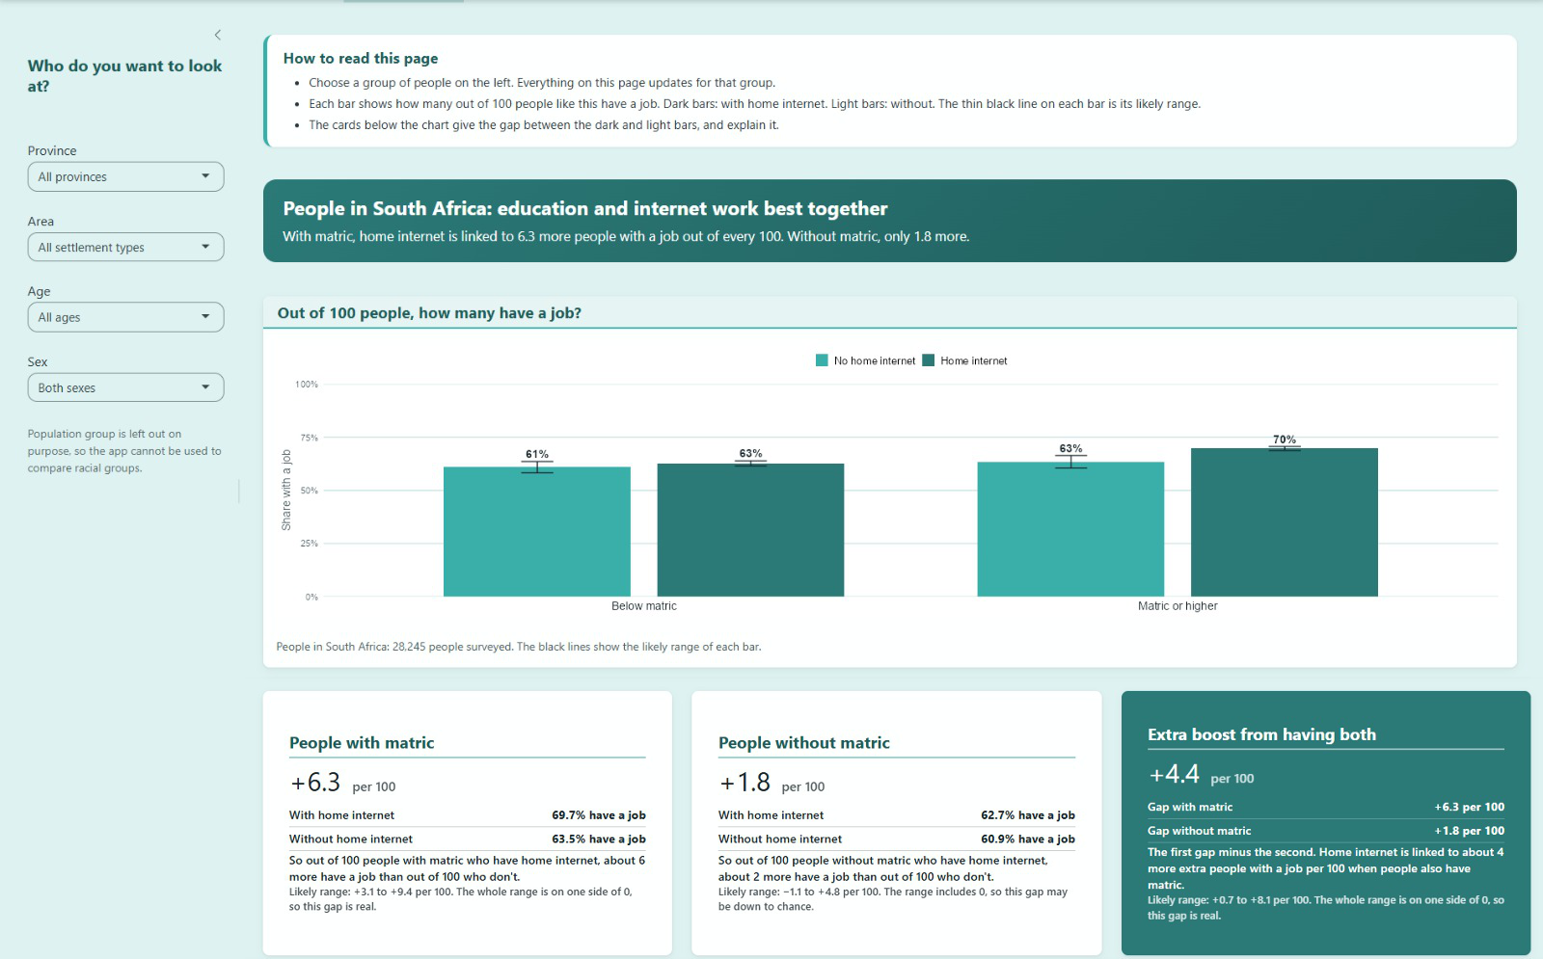
For a chosen group (province, area, age band, sex), the expected employment rate of the four matric × internet combinations, with likely ranges, and the gaps between them explained in each card.

Province scenarios
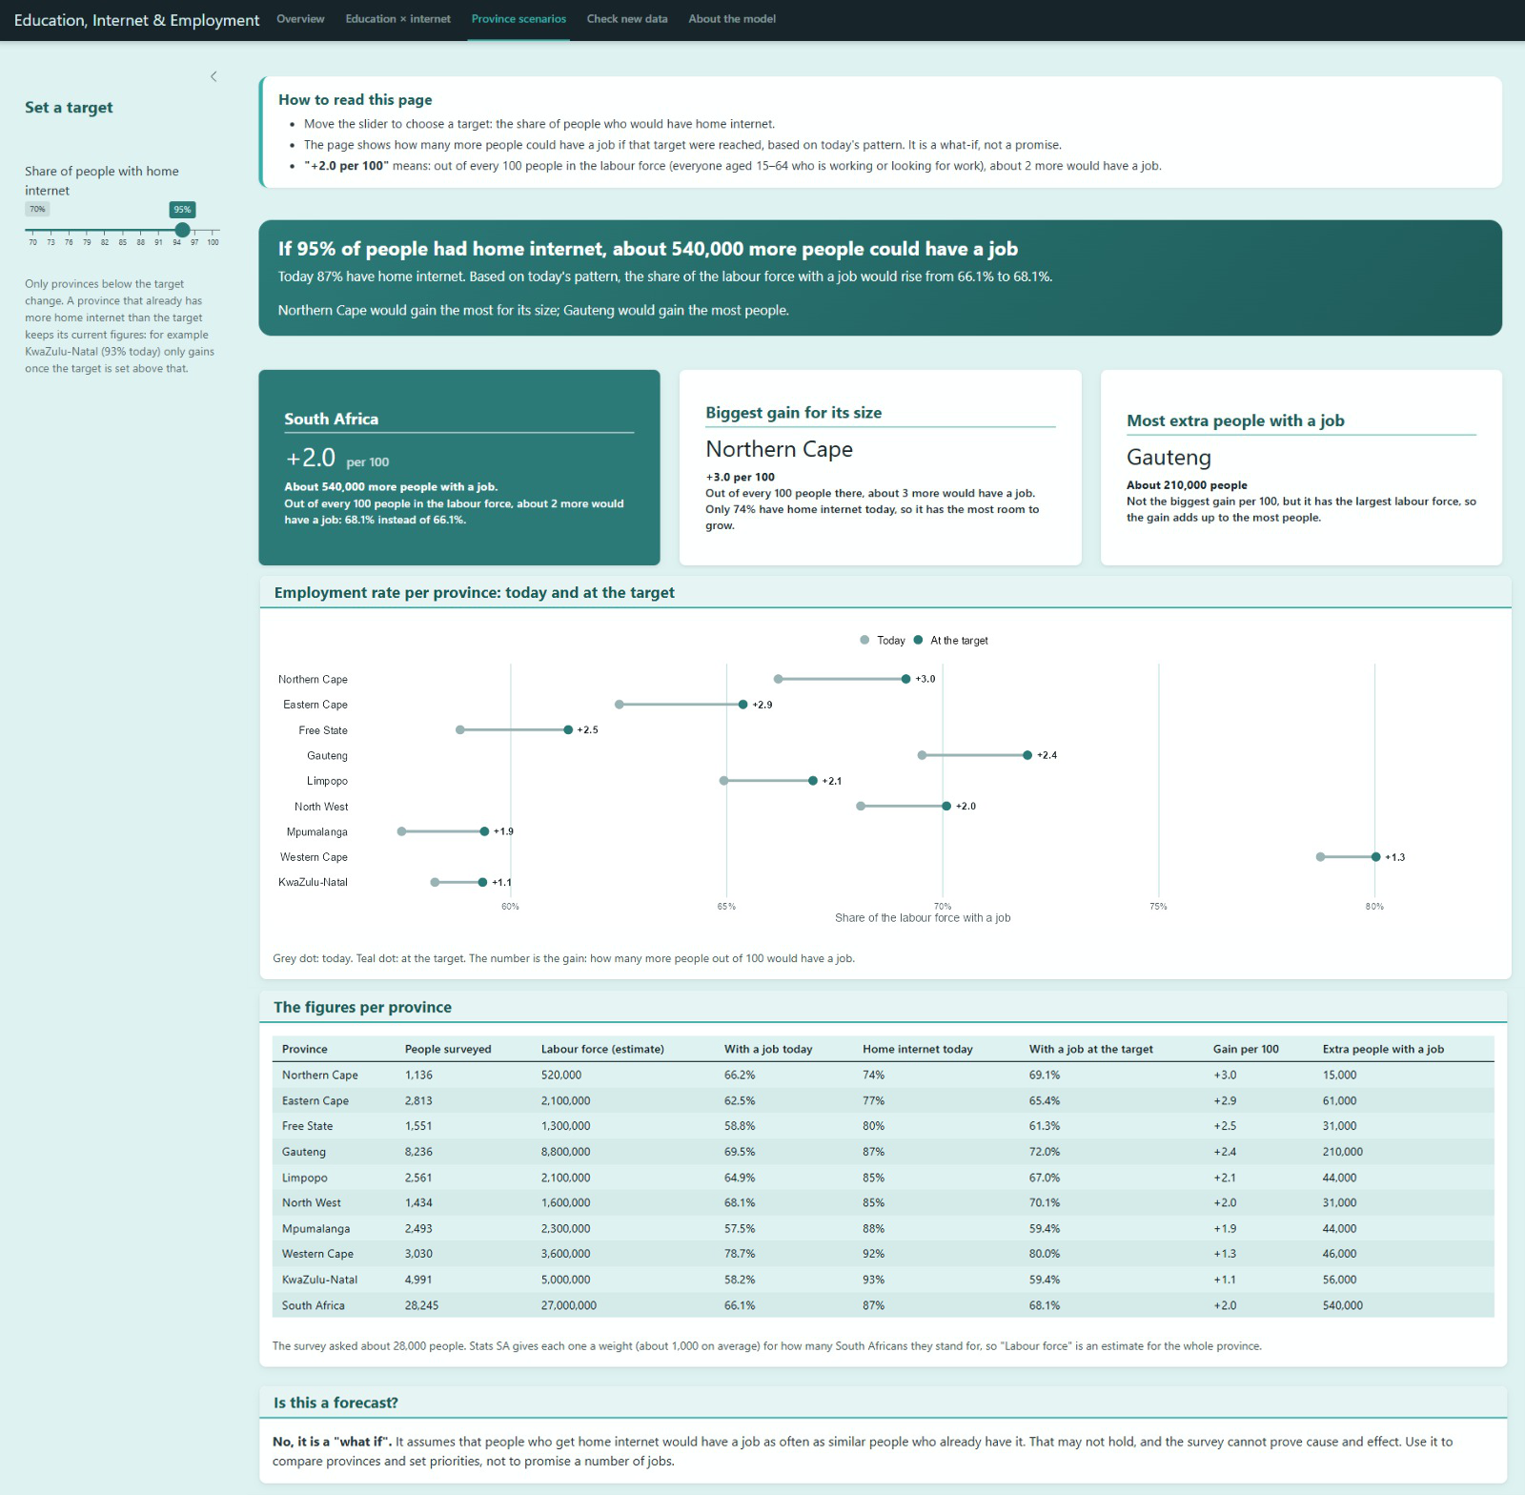
What the model's pattern implies if a target share of people had home internet: the employment rate and the approximate number of additional people with a job, per province and nationally. This is clearly labelled as a "what if", not a forecast.

Check new data
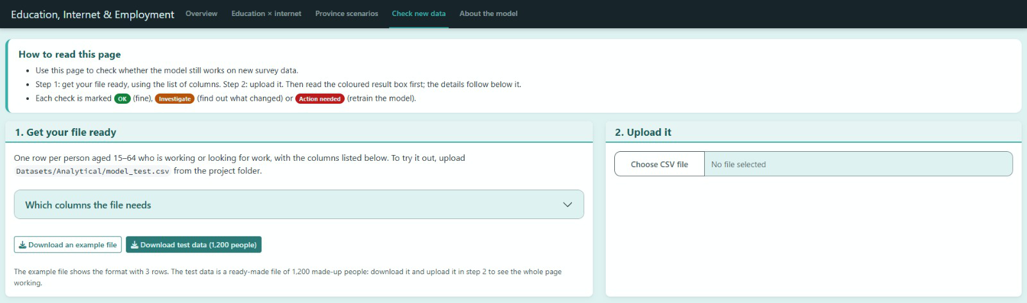Upload a CSV file: the application validates it, shows the predicted employment rate per group, measures accuracy against the actual outcomes, and runs the monitoring checks. An example file and a ready-made test file of 1,200 made-up people can be downloaded.

About the model
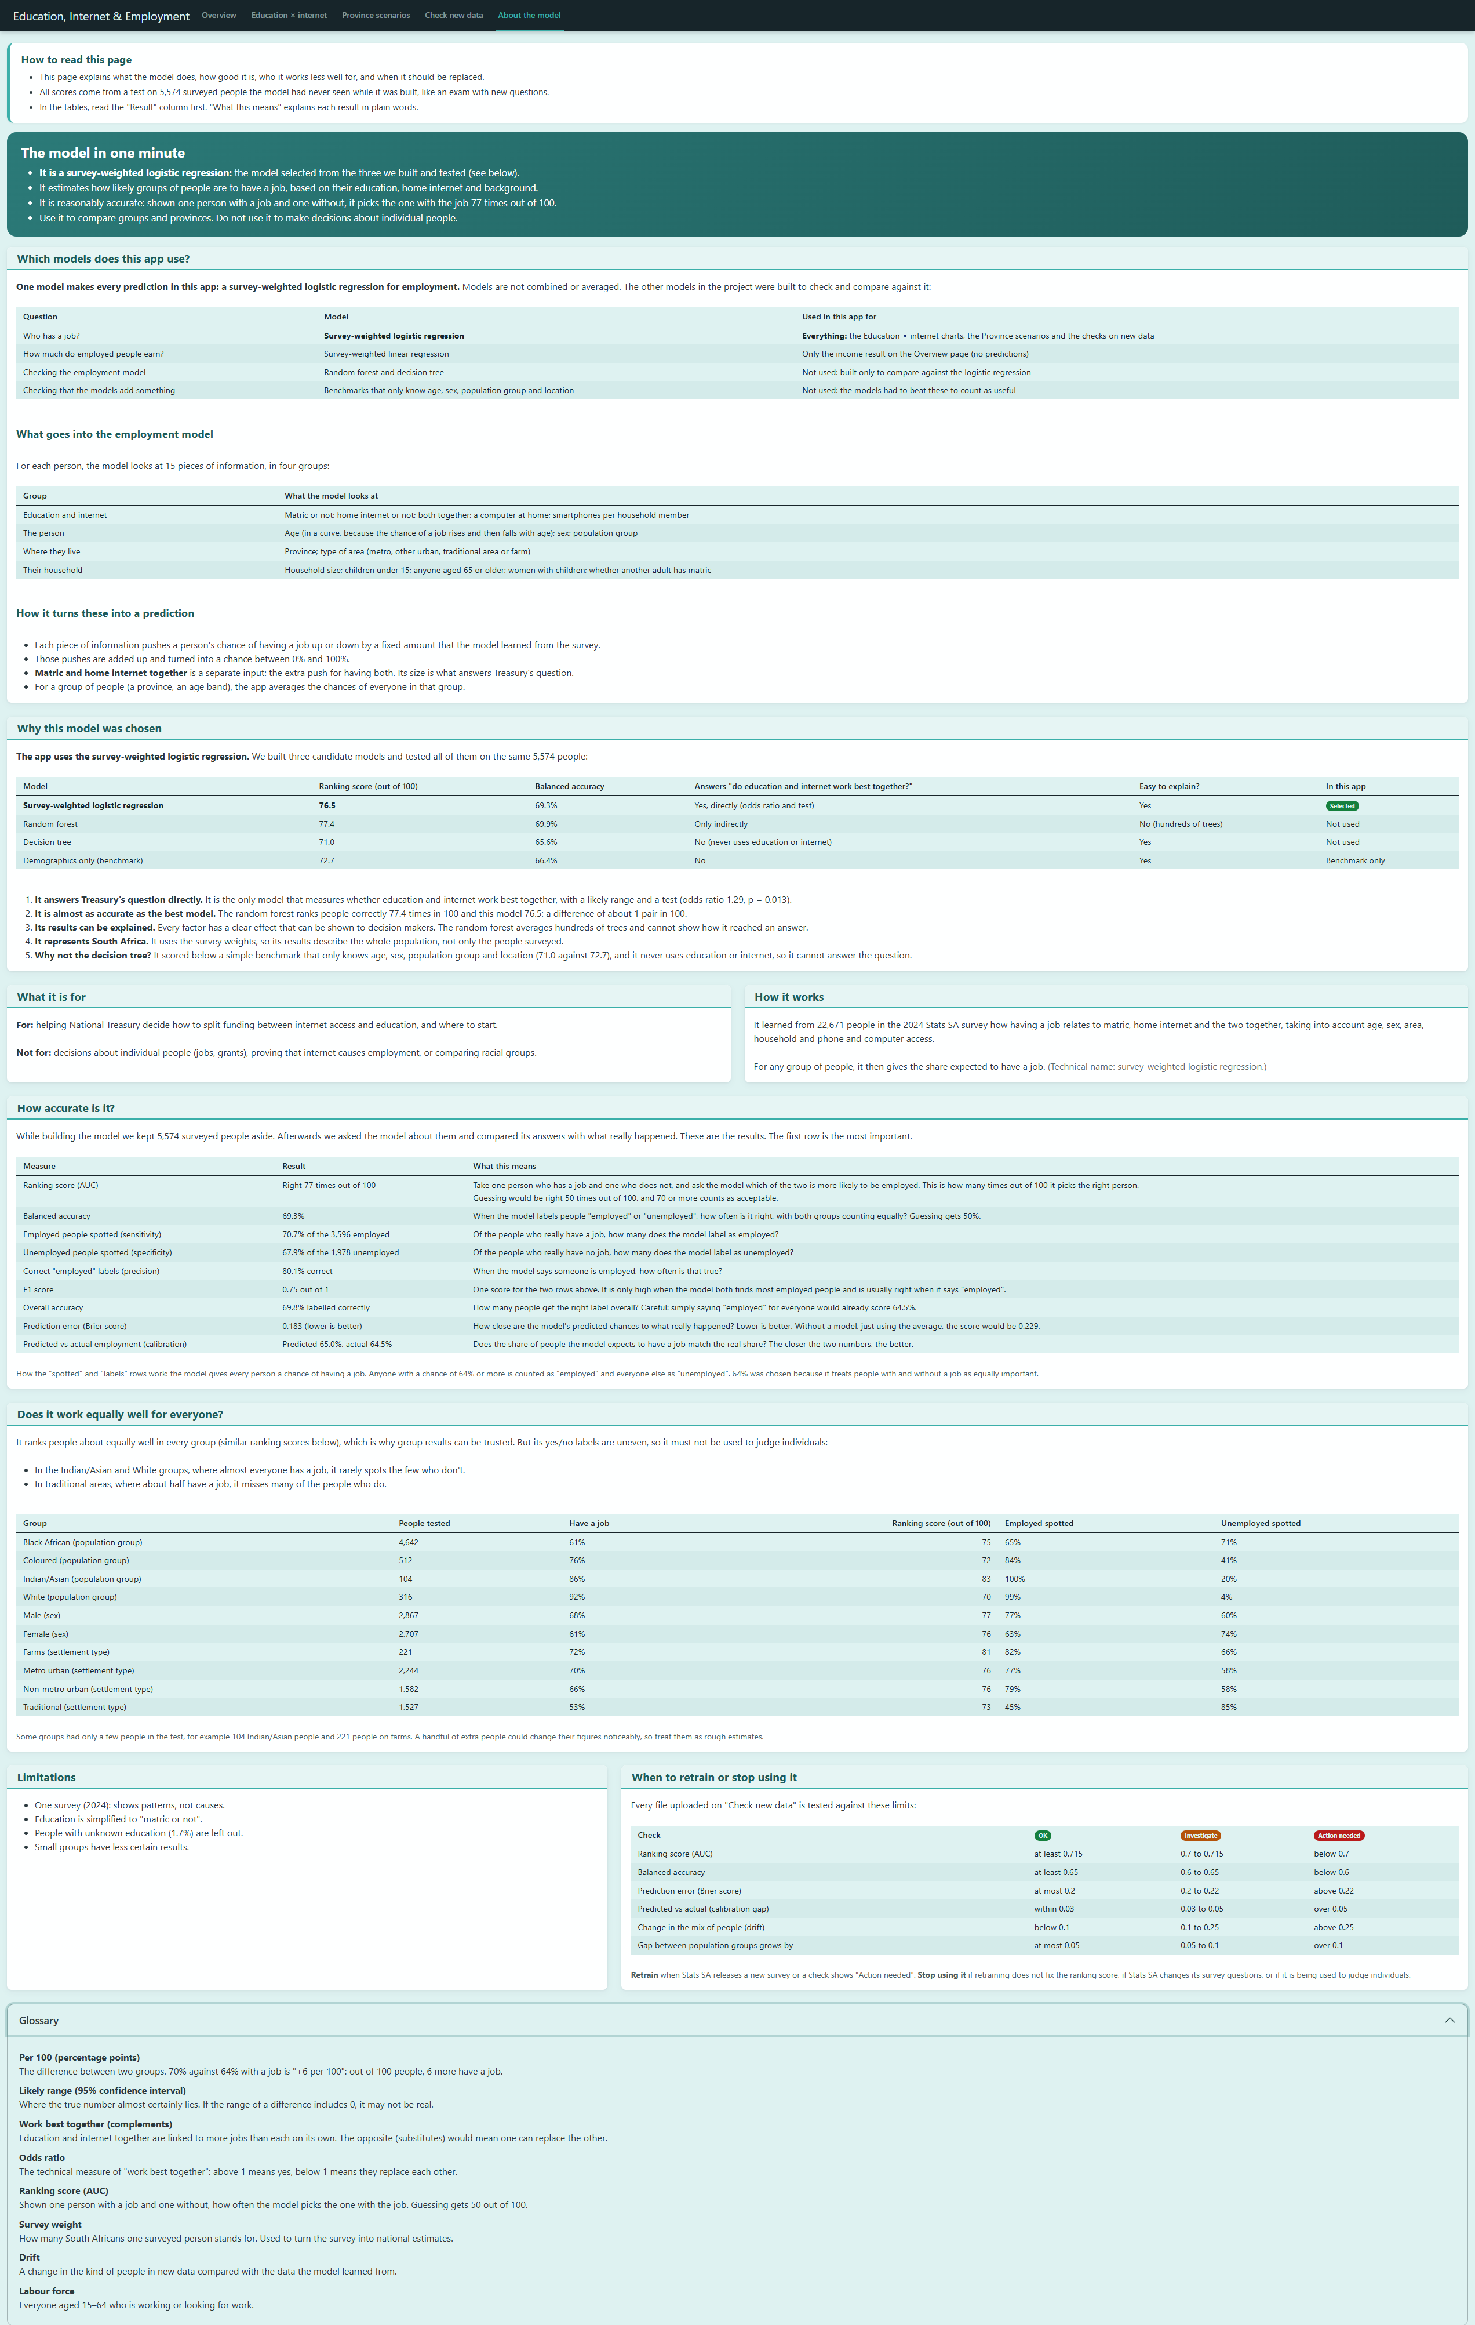

Which models are used and why the logistic regression was selected, what goes into the model, how accurate it is, how it performs for different groups, its limitations, and when it should be retrained or retired. It also has a glossary.

Design choices for responsible use:
- Population group is not a filter. Results are averaged over the real mix of people in the chosen group, so the application cannot be used to compare the employment chances of racial groups. Population group stays in the model only as a control.
- Small groups are hidden. Filter combinations with fewer than 50 people in the survey are not shown, because their estimates would be unreliable and could identify people.

21.5 How the application uses the model without the survey data
The saved model file (Models/employment_logistic.rds) contains a full copy of the training data, including every household identifier, because the svyglm function stores it. A deployed application must not carry survey microdata: if the application were hosted online, the data would be published with it.
Notebook Scripts/3.4) Deployment Preparation.qmd therefore builds a separate file, Shiny-App/app_data.rds, that contains only:
- the "slim" model: its 30 coefficients, their covariance matrix and the formula and category definitions. The notebook confirms that it predicts exactly like the full model.
- pre-calculated group results for every filter combination on the Education × internet page.
- province totals for the scenarios.
- the test-set results that the monitoring checks compare new data with.
- the training data's mix of people, for the drift check.
Every item is a model parameter, a total or an average. None is a row of survey data. Because of this, the application could also be hosted on a service such as shinyapps.io without publishing any survey records.

21.6 Validating and scoring new data
On the "Check new data" page, an uploaded CSV file goes through these steps:
- Read every column as text, so that a value of the wrong type is reported instead of silently becoming missing.
- Validate the file:
  - all 15 predictor columns must be present, otherwise the file is rejected and the missing columns are named.
  - numbers must be numbers, 0/1 columns may only contain 0 or 1, and values must be in range.
  - category columns may only contain the values the model was trained with.
  - calculated columns must agree with the columns they are made from.
  - rows with unknown education are left out, as in the training data.
  - a warning is shown when fewer than 200 rows can be used.
Rows that fail a check are left out, and the report states how many and why.
- Prepare the valid rows with exactly the same function used for the training data, so new data is always processed the same way as the data the model learned from.
- Predict each person's chance of having a job with the slim model, and show the results per group only.
- If the file contains the actual outcome (employed), measure accuracy and run the monitoring checks.
The application shows the result first, in plain words: whether the file is usable, the predicted employment rate, whether accuracy is as expected, whether the data resembles the training data, and what to do next.
A test file with 1,200 made-up people (Shiny-App/dummy_employment_test_data.csv) can be downloaded in the application. Its mix of people matches the training data, and its outcomes were simulated from the model's own predictions. Uploading it gives "No action needed" with every check passed. Uploading the real test set (Datasets/Analytical/model_test.csv) reproduces the evaluation results exactly.

21.7 Monitoring, retraining and retirement
Every upload is compared with the model's performance on the test set. Each check is marked OK (green), Investigate (yellow) or Action needed (red). The thresholds are defined in one place, Shiny-App/monitoring.R.

Check | What it measures | Test-set value | OK | Investigate | Action needed
Ranking score (AUC) | How well the model tells employed and unemployed people apart | 0.765 | ≥ 0.715 | 0.70 - 0.715 | < 0.70
Balanced accuracy | Share labelled correctly, with both groups counting equally | 0.693 | ≥ 0.65 | 0.60 - 0.65 | < 0.60
Brier score | How close the predicted chances are to what happened | 0.183 | ≤ 0.20 | 0.20 - 0.22 | > 0.22
Calibration gap | Predicted minus actual employment rate | 0.005 | within ±0.03 | ±0.03 - 0.05 | beyond ±0.05
Drift (population stability index) | Change in the mix of province, area type, population group, age, education, home internet and smartphone access compared with the training data | ≈ 0 | < 0.10 | 0.10 - 0.25 | > 0.25
Fairness gap | Widening of the gap between the best and worst population group's AUC | 0.133 | ≤ +0.05 | +0.05 - 0.10 | > +0.10
The drift checks do not need the actual outcome, so they run on every upload. The accuracy and fairness checks need the employed column. Files with fewer than 200 usable rows are reported as "not checked", because the measures would be dominated by chance.
When to act:
- Retrain (rerun notebooks 2.1 to 3.4 on the new data) when Statistics South Africa releases a new survey wave, or when any check is marked "Action needed".
- Investigate when a check is marked "Investigate": find out whether the data comes from a different population or collection method before relying on the results.
- Retire the model when:
  - Retraining does not bring the AUC back above 0.70.
  - Statistics South Africa changes the definitions of the education or internet questions, so new data no longer means what the model learned.
  - The education × internet interaction is no longer significant in successive survey waves, so the "work best together" finding no longer holds.
  - The application is found to be used for decisions about individual people, which it was not designed for.

21.8 Reproducibility and repository
All deployment code is in the project repository:
Location | Contents
Scripts/3.4) Deployment Preparation.qmd | Deployment strategy, building and checking the slim model, the app's data file and the monitoring baseline
Scripts/R/model_preparation.R | Data preparation shared by the modelling notebooks and the application
Shiny-App/app.R | The application
Shiny-App/app_data.rds | The slim model and aggregated tables the application load
Shiny-App/deployment_model.R, validate_input.R, monitoring.R | Prediction, validation of new data, accuracy measures and monitoring thresholds
Every random step uses seed 67, so rerunning the notebooks in order reproduces the same models and the same application data. Each code file starts with a commented-out install.packages() line listing the packages it needs. The rendered notebooks are saved in Documentation/Rendered Documentation/.

22. Conclusion
This milestone assessed how access to digital technologies can influence the employment and income outcomes associated with education, using several modelling techniques and data from a 2024 survey conducted in South Africa. The results clearly show that education and digital access are complements rather than substitutes for employment. The survey weighted logistic regression achieved a test AUC of 0.765 and found a significant matric x home internet interaction. The same pattern was also found with the independently fitted random forest, and the interaction remained significant after the device ownership predictors were removed. The employment success criteria established in previous milestones were therefore fulfilled.
The income analysis revealed a different outcome. While education and home internet access were found to be related to salary, there was no statistically significant interaction between matric and home internet access. Therefore, there is no evidence from this analysis that home internet access changes the salary premium associated with matric among those who reported a salary. The income results should therefore be considered exploratory and should not be combined with the employment results into a single conclusion.
For the stakeholder, the results suggest that digital access may support the value of education and is associated with stronger employment outcomes among people with matric. However, the analysis is not causal and only shows an association. The findings do not prove that providing internet access would lead to an increase in employment, as the data come from a single cross-sectional survey. The results should therefore be interpreted as evidence to support further research and policy consideration rather than as proof of a specific intervention effect.
The evaluation also shows that overall model performance is not necessarily representative of the model's performance across all population groups. Significant differences in sensitivity and specificity were found between population groups, sex and settlement type. Therefore, the selected employment model is better suited to analysing group level relationships and assessing "what-if" scenarios than to making decisions about individuals. Any future deployment should continue to report subgroup performance and monitor these differences using new data. The model should also not be used as the sole basis for making individual-level decisions.
Overall, the modelling provides a satisfactory answer to the key business question: digital access and education appear to reinforce each other in their relationship with employment, but this relationship cannot be considered causal. The findings provide some support for considering connectivity investment alongside education investment, while also highlighting the limitations of the available data and the importance of fairness, transparency and ongoing evaluation.

References
Breiman, L., Friedman, J.H., Olshen, R.A. and Stone, C.J., 1984. Classification and
Regression Trees. Belmont, CA: Wadsworth.

Chang, W., Cheng, J., Allaire, J.J., Sievert, C., Schloerke, B., Xie, Y., Allen, J., McPherson,
J., Dipert, A. and Borges, B., 2026. shiny: Web Application Framework for R. R package.

DeLong, E.R., DeLong, D.M. and Clarke-Pearson, D.L., 1988. Comparing the areas under
two or more correlated receiver operating characteristic curves: a nonparametric approach.
Biometrics, 44(3), pp.837–845. doi:10.2307/2531595.

Kuhn, M., 2026. caret: Classification and Regression Training. R package version 7.0-1.

Lumley, T., 2004. Analysis of complex survey samples. Journal of Statistical Software,
9(1), pp.1–19. doi:10.18637/jss.v009.i08.

Lumley, T., 2026. survey: Analysis of Complex Survey Samples. R package version 4.5.

R Core Team, 2026. R: A Language and Environment for Statistical Computing. Vienna: R
Foundation for Statistical Computing.

Rao, J.N.K. and Scott, A.J., 1981. The analysis of categorical data from complex sample
surveys: chi-squared tests for goodness of fit and independence in two-way tables. Journal
of the American Statistical Association, 76, pp.221–230.

Statistics South Africa, 2025. General Household Survey 2024. Pretoria: Statistics South
Africa.

Therneau, T. and Atkinson, B., 2026. rpart: Recursive Partitioning and Regression Trees. R
package version 4.1.27.

Wright, M.N. and Ziegler, A., 2017. ranger: A fast implementation of random forests for high
dimensional data in C++ and R. Journal of Statistical Software, 77(1), pp.1–17.
doi:10.18637/jss.v077.i01.

